Learning to Live, Living to Learn  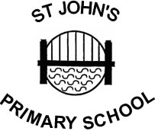 | St John’s Primary School.  Teindland Close,  Newcastle upon Tyne,  NE4 8HE.  Telephone : 0191 – 273 5293  Fax : 0191 – 273 0651  e. mail – tracey.caffrey@stjohns.newcastle.sch.uk  Headteacher : Tracey Caffrey
10th December 2020

Dear parents,

On Tuesday, all schools were informed by the Department for Education that our staff are expected to be on call for the first six days of the school holidays to support with track and trace. This means that if any children or staff develop Covid-19 symptoms, we are asked to notify Public Health England and then contact all possible close contacts within the school community.

To ensure this doesn’t mean us being on call over Christmas, we have been advised by the DfE to take Monday 21st Dec as a training day. This means that our last day in school is Friday 18th December. As there is no enrichment session next week, pupils should be collected on the 18th at the following times:
Nursery | 12pm
Reception | 1.30pm
Years 1 and 2 | 1.20pm
Years 3 and 4 | 1.25pm
Years 5 and 6 | 1.15pm

I am sorry for the short notice and appreciate that this might cause childcare issues for families, but we only received the information this week and needed to consult with the governors and our Local Authority before informing parents. We return to school on Wednesday 6th January.

IMPORTANT: If your child develops any Covid-19 symptoms during the first week of the holidays, please inform me and arrange a test. If the result is positive, it is vital that you let me know so that I can inform Public Health and the parents of any children they might have had contact with in school. You can message me on Class Dojo, text 07815968699 or email tracey.caffrey@stjohns.newcastle.sch.uk

Christmas parties have been brought forward and will now happen for all year groups on Thursday 17th December. Santa has changed his plans too and will visit school next week to see children in Early Years and Years 1, 2 and 3!

Don’t forget tomorrow (11th) is Christmas Jumper Day. Wear something festive for a £1 donation to Save the Children.

One final reminder please – if you are entitled to Free School Meals, you will be sent a £30 shopping voucher via email. Miss Bartley has sent you an email that you need to respond to before this can happen. PLEASE check your email and respond.

Wishing you a safe and happy holiday,
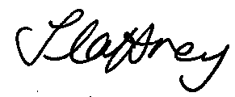

Mrs T Caffrey

