February 2021
[Type a quote from the document or the summary of an interesting point. You can position the text box anywhere in the document. Use the Drawing Tools tab to change the formatting of the pull quote text box.]

A huge thank you for your support during what has been another difficult term.

We have over 100 vulnerable and key worker children in school every day and are incredibly proud to say that almost EVERY child in school is engaging in online Teams lessons so that no learning is lost! This is an amazing achievement, and I want to say a huge thank you to all of the staff who have worked so hard to make it happen and all of you parents at home for supporting your children so brilliantly. If you are a key worker or believe that your child is ‘vulnerable’ please get in touch about a school place.

All staff in school are being tested twice a week to identify any positive cases quickly and prevent the spread of infection. We have only had one positive case in school this term and by having robust track and trace systems in place, we were able to make sure there were no further cases.

I know many of you are very keen for your children to get back in to school again. My understanding is that this will be sometime after 8th March and that we should find out more after half term. We can’t wait to have everyone back but this needs to happen safely.

Please help us to keep it this way by keeping your child at home if they have a new and persistent cough, a high temperature or if they lose their sense of smell. Other symptoms of Covid in children can include tiredness, a cold/runny nose, a sore throat and sickness/diarrhoea. So if your child is unwell, it is better to be safe than sorry and arrange a test. Let school know straight away if someone in your house has symptoms or if you’ve been in contact with a person who has tested positive. Arranging a test is much easier now and results are coming back within a day or so, so a negative result means we can get your child back quickly. If you need to inform us of a positive Covid case during half term, please message me directly on Class Dojo or text the school mobile on 07815968699.

If you are struggling and need some support with food, fuel, emergency household electricals or cleaning products/toiletries/baby goods, please fill in the survey on Dojo/Seesaw and Mrs Lishman will get back to you.

Devices and internet
If your child is still using a phone to access home learning – please get in touch to borrow a tablet or laptop. We have free BT wifi codes and Vodafone Sim cards that are easy to set up and will provide a free, reliable data connection.

Free school meals
The government has confirmed that Free School Meals vouchers will continue to be provided through February half term. If you think your circumstances have changes and you might be eligible to apply for FSM now, you can do it online
https://www.newcastle.gov.uk/services/schools-learning-and-childcare/help-school-and-learning-costs/apply-free-school-meals

Half term fun!
The weather is pretty miserable right now and there’s not a lot we can do outdoors, so we’ve put our heads together and come up with some fun things to do in the holidays. Every child in school will be given a half term activity pack full of things to keep them busy. Parents will be invited to collect packs for children learning at home sometime next week. Packs may include art and crafts, cooking ingredients and recipes, games, books etc. Please encourage your child to spend time enjoying the activities and upload some pictures/videos to Seesaw/Tapestry so that we can see what they got up to!

Wraparound care
We have a few places left at wraparound care. This is a childcare provision that runs from the end of school until 5pm Mon-Thurs. For just £2 per child per day, your child is cared for and has a hot meal! To book a place, speak to Miss Bartley. We ask for payment upfront to secure your place.

Exciting news!
We’ve got some news that we’ve been dying to tell you, but Covid just keeps getting in the way! Anyway, I think we all need something to look forward to so here it is…

Thanks to a very generous donation, we have bought our very own mobile home for our St John’s families to be able to enjoy free holidays! The caravan sleeps 6 people and is based at Whitley Bay Caravan Park. It is newly refurbished, has central heating and double glazing, so can (eventually) be used all year round! There’s an indoor pool, adventure playground and clubhouse on the park and it is just a stone’s throw from the beach. We can’t wait until we can offer it out to families and I’ll keep you posted once we get the green light from the government that holiday parks can reopen.

There’ll be a booking system in place but we’re not going to open it up to families until we know that holidays can definitely go ahead. Watch this space..!
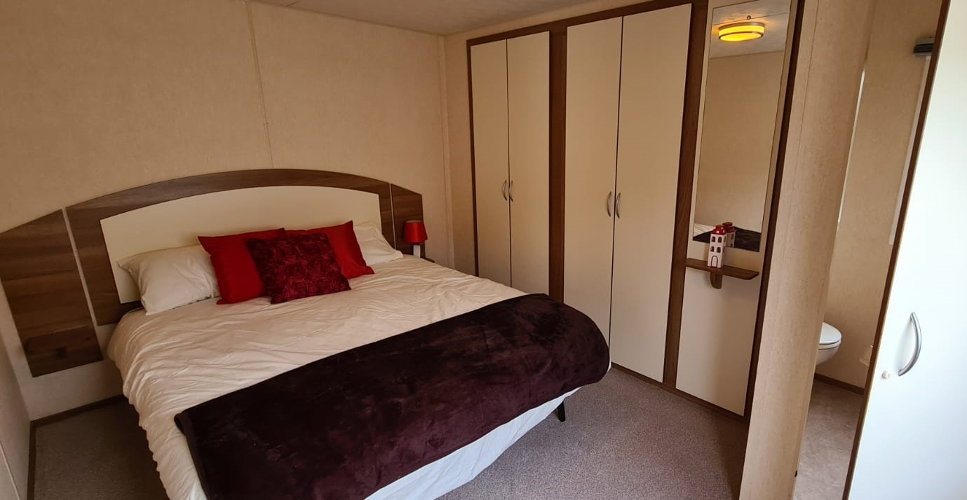
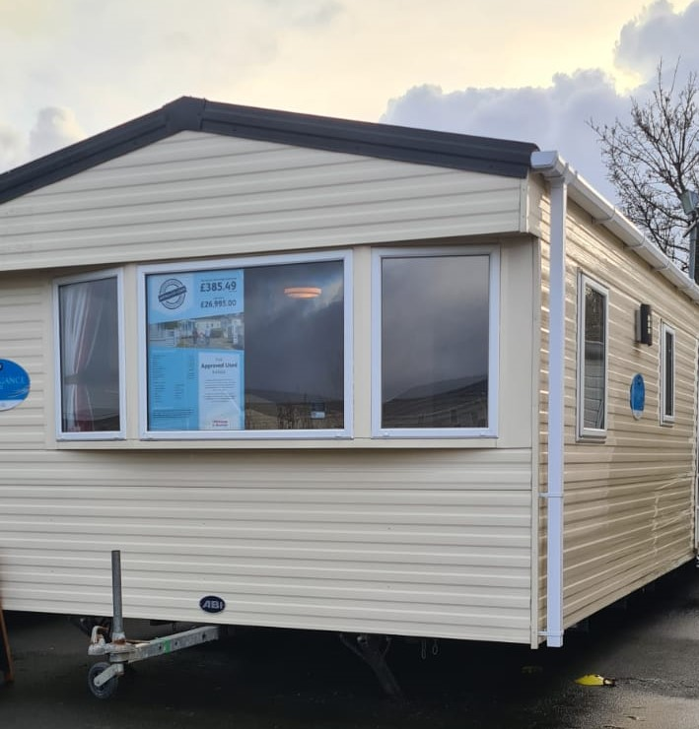
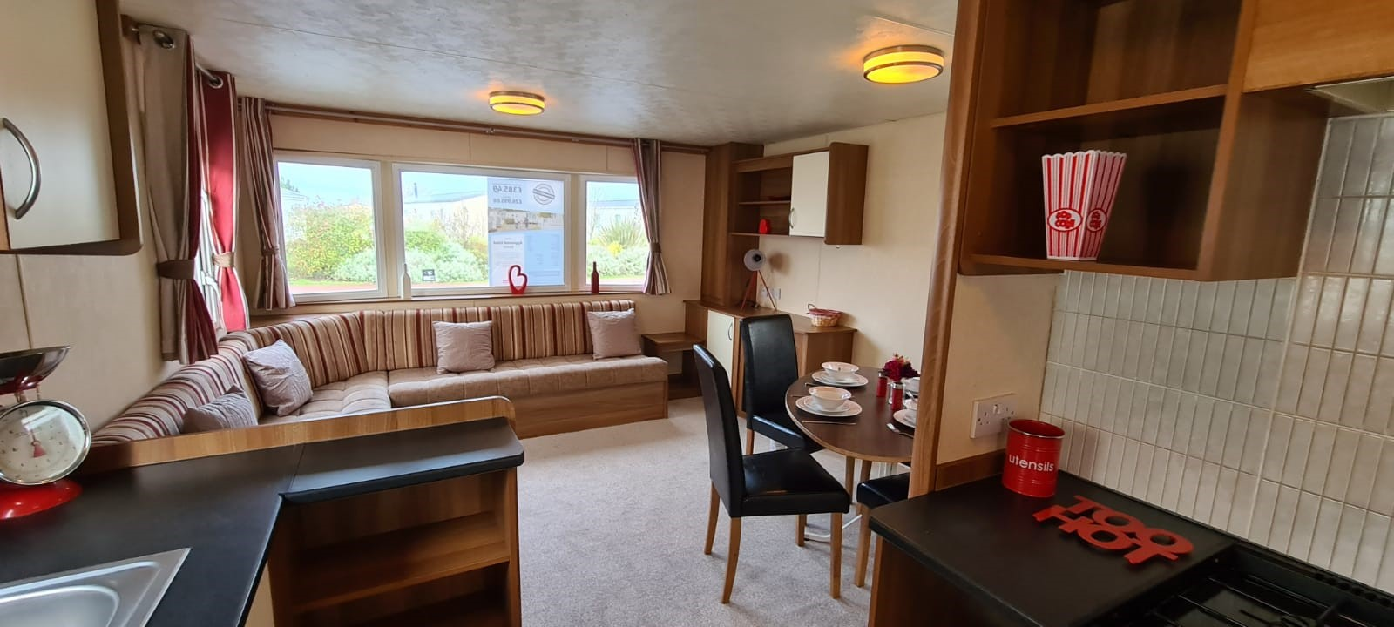

Term dates and holidays
Spring Term Wednesday 6th January – Thursday 1st April 2021
Half term holiday – break up Friday 12th Feb, return Monday 22nd Feb
Easter holiday – break up Thurs 1st April, return Monday 12th April

Summer Term Monday 12th April – Friday 23rd July 2020
Bank holiday Monday 3rd May
Half term holiday – break up Friday 28th May, return Monday 14th June

A copy of our 2021-22 term and holiday dates is now on the website.

