Learning to Live, Living to Learn  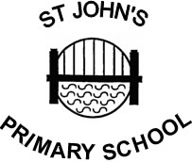 | St John’s Primary School.  Teindland Close,  Newcastle upon Tyne,  NE4 8HE.  Telephone : 0191 – 273 5293  Fax : 0191 – 273 0651  e. mail – tracey.caffrey@stjohns.newcastle.sch.uk  Headteacher : Tracey Caffrey
8th October 2020
Dear parents and carers,

The Department for Education has announced changes to Relationships and Sex Education (RSE) statutory guidance. These changes came into effect from September 2020 and all schools are required to comply with the updated requirements.

In light of these changes, we are reviewing our PSHE curriculum and policy, so we can be sure our provision is appropriate for our pupils based on:
• Age and maturity levels, as well as their cultural and religious backgrounds
• The values of our school community
• Every pupil’s learning needs
• What pupils need to know to be healthy and safe in school, in their personal relationships and in the wider world
• What pupils need to know in order to be prepared for puberty and give them an understanding of, and the importance of, health and hygiene
• The importance of developing feelings of self-respect, confidence and empathy
• Creating a positive culture around issues of safe loving relationships

At St John’s, we teach sex education in line with the statutory Primary Science curriculum. Our PSHE curriculum is about the emotional, social and cultural development of pupils and involves learning about positive relationships, healthy lifestyles, diversity and personal identity. It involves a combination of sharing information and exploring issues and values in a safe and secure environment. Our PSHE curriculum underpins our whole school ethos and in addition to this, is taught in discrete lessons.

To help ensure our PSHE curriculum incorporates not only the statutory guidance, but also our school’s needs, we are consulting parents.

Stage 1: Online consultation
Due to Covid-19 we are unable to offer any face to face consultations or workshops but have uploaded important documents and a presentation for you to read here on the school website.
Parents will be invited to respond to the proposed curriculum and policies via a short questionnaire that can be found here.

Stage 2:
Following the Stage 1 consultation, we will update our PSHE curriculum and policy taking in to account any feedback or suggestions. You will all receive a copy of our new draft curriculum and policy and it will be available on our website. It will then be ratified by Governors.

Thank you for taking the time to participate in this consultation.

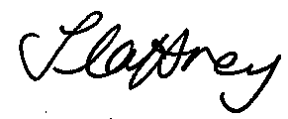
Mrs T Caffrey

